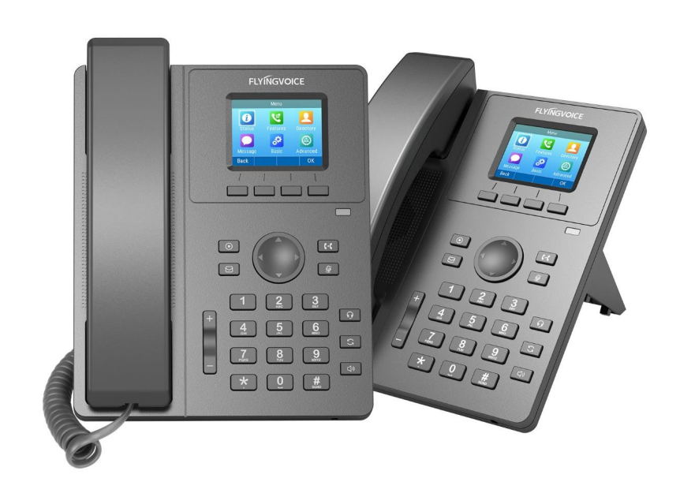

**Ring Group Configuration Guide**

**Directory**

一、 Introduction 2

二、 Flow Configuration 2

1、 Configuring FreePBX 2

① Set Ring Groups 2

三、 Verification of Results 2

1. **Introduction**

The Ring Groups module is used to create a single extension number that your users can dial in order to ring multiple extensions at the same time. It also creates a destination to which you can send calls that will ring those multiple extensions.

1. **Flow Configuration**
2. **Configuring FreePBX**
3. **Set Ring Groups**

Create a ring-group number.

**operating steps：**

Applications--》Ring Groups--》Add Ring Group；

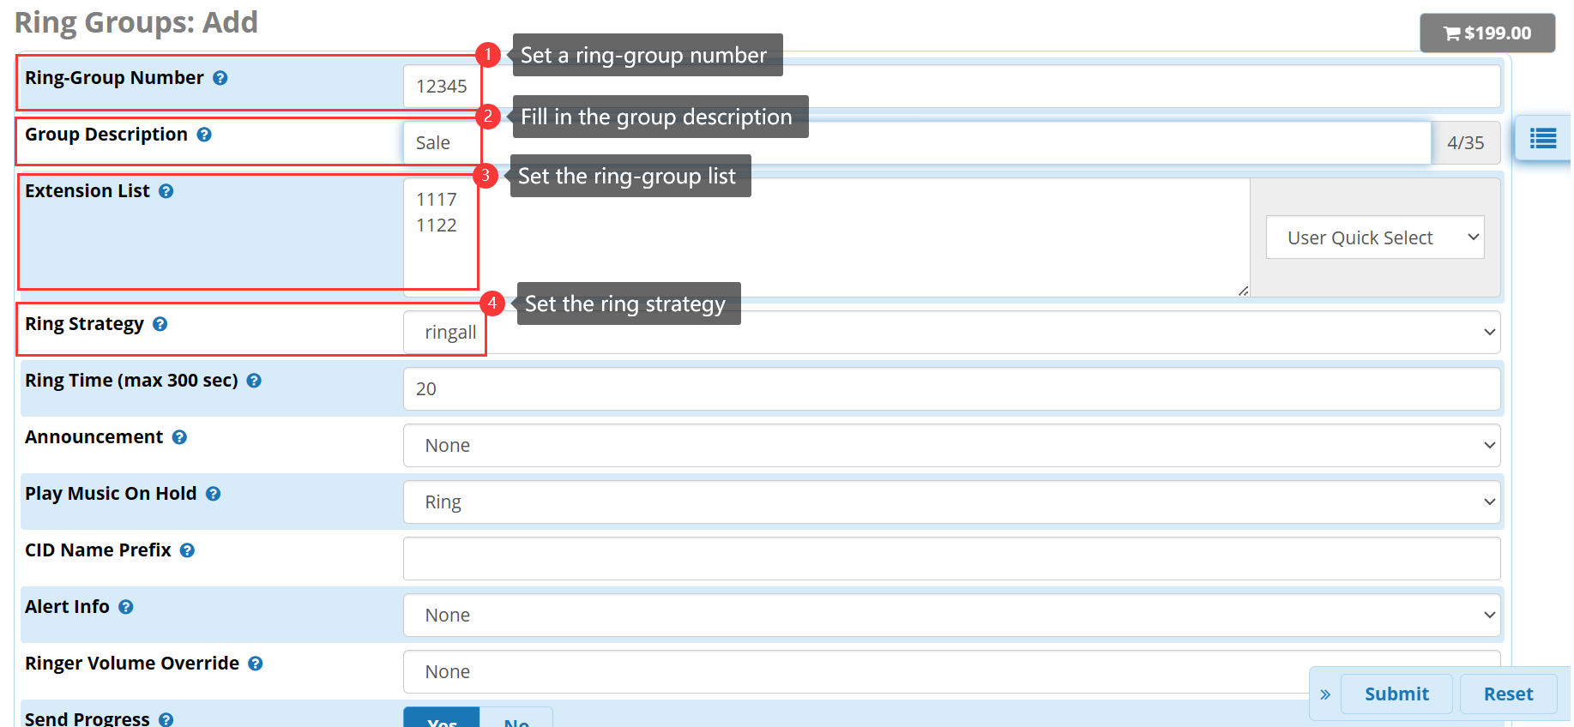

Figure 1 set ring groups

**Ring strategy:**

**ringall:**This will ring all available channels simultaneously until someone answers. This is the default.

**hunt:**This will take turns ringing each available extension one at a time.

**memoryhunt:**This will ring the first extension in the list. After that, it will ring the 1st and 2nd together, then the 1st, 2nd and 3rd extensions together, and so on.

**\*-prim:**This suffix changes the behavior of the other ring strategies. When -prim is selected, the first extension listed becomes the "primary" extension.

**firstunavailable:**This will only ring the first available channel.

**firstnotonphone:**This will only ring the first channel that is not off-hook, ignoring call waiting.

**random:**Calls ring extensions without a predefined priority in a random order. This helps spread ring group calls evenly among the group, which can simulate queue behavior when a queue cannot be used.

1. **Verification of Results**

When user dials 12345, extensions 1117 and 1122 ring simultaneously.